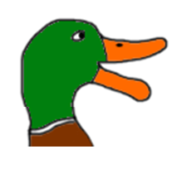**D. U. C.**   **. S**

**Game Design Report**

Sam Neville, Charlie Lloyd-Buckingham, Dan Udal, Connor Morris-Cross, Paul Brown

**Who are we?**

We are **D.U.C.K.S!** **Dynamic Undergraduates Creating Killer Software**!

We are made up of 3 students on **Game Software Engineering** and 2 students from **Games Design**.

**Our members are:**

**Sam Neville:**

* Group Leader
* General – Programmer
* Concept Designer

**Charlie Lloyd-Buckingham:**

* General – Programmer
* Artist and Animator
* 3D Model Design and Creation
* Concept Designer

**Daniel Udal:**

* Specialised – Programmer
* Concept Designer

**Paul Brown:**

* Environment Artist
* VFX Designer
* Concept Designer

**Connor Morrell-Cross:**

* Level Designer
* Concept Designer